**DAILY ONLINE ACTIVITIES SUMMARY**

|  |  |  |  |  |  |  |  |
| --- | --- | --- | --- | --- | --- | --- | --- |
| **Date:** | 09/06/2020 | | | | **Name:** | AMBIKA V | |
| **Sem & Sec** | 4th Sem Section'A' | | | | **USN:** | 4AL18CS005 | |
| **Online Test Summary** | | | | | | | |
| **Subject** | | - | | | | | |
| **Max. Marks** | | - | | **Score** | | - | |
| **Certification Course Summary** | | | | | | | |
| **Course** | Introduction to Apache kafka | | | | | | |
| **Certificate Provider** | | | greatlearning academy | **Duration** | | | 3 hrs |
| **Coding Challenges** | | | | | | | |
| **Problem statement 1:**Write a C Program to rotate the matrix by K times Program in C | | | | | | | |
| **Status:** completed | | | | | | | |
| **Uploaded the report in Github** | | | | yes | | | |
| **If yes Repository name** | | | | https://github.com/ambika0202/C-Coding | | | |
| **Uploaded the report in slack** | | | | yes | | | |

**ONLINE TEST DETAILS: N/A**

**CERTIFICATION COURSE DETAILS:**

**Name of the course**: Introduction to Apache Kafka

**Certificate Provider**: Great Learning Academy

Today I have started a new in Greatlearning Academy.

**About this course**

This is an introductory course on one of the most used tools in big data - Hive. Hive is an ETL and data warehouse infrastructure software that can create interaction between user and Hadoop Distributed File System (HDFS). The course starts with the introduction to Hive before progressing to next topics which utilise a hands-on approach to explain. You will learn internal and external table structures, reading data from different formats into Hive structure. With the help of easy and intuitive explanation, you will get a good grasp on how to load data into Hive, querying techniques as well as generating views in Hive tables.

**Skills covered**

* Hive querying
* Hive data upload
* Hive

**Course Syllabus**

* Introduction to Apache Hive
* Intro to hive
* Hive demo - basics and internal table
* Hive demo - external table
* Hive demo - loading different file formats
* Hive demo - load data into hive table
* Hive demo - simple operations on hive table
* Hive demo - query operations on hive table
* Hive demo - querying complex structures from a table

**Snapshot:**

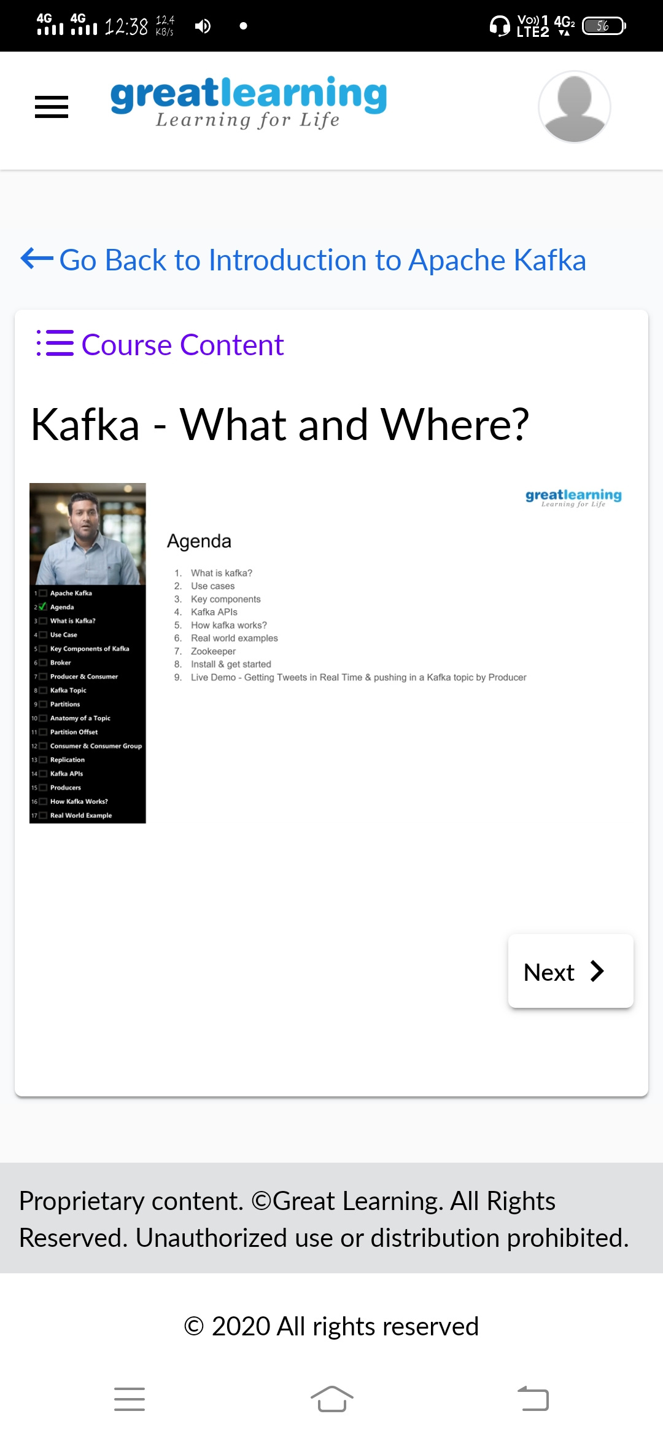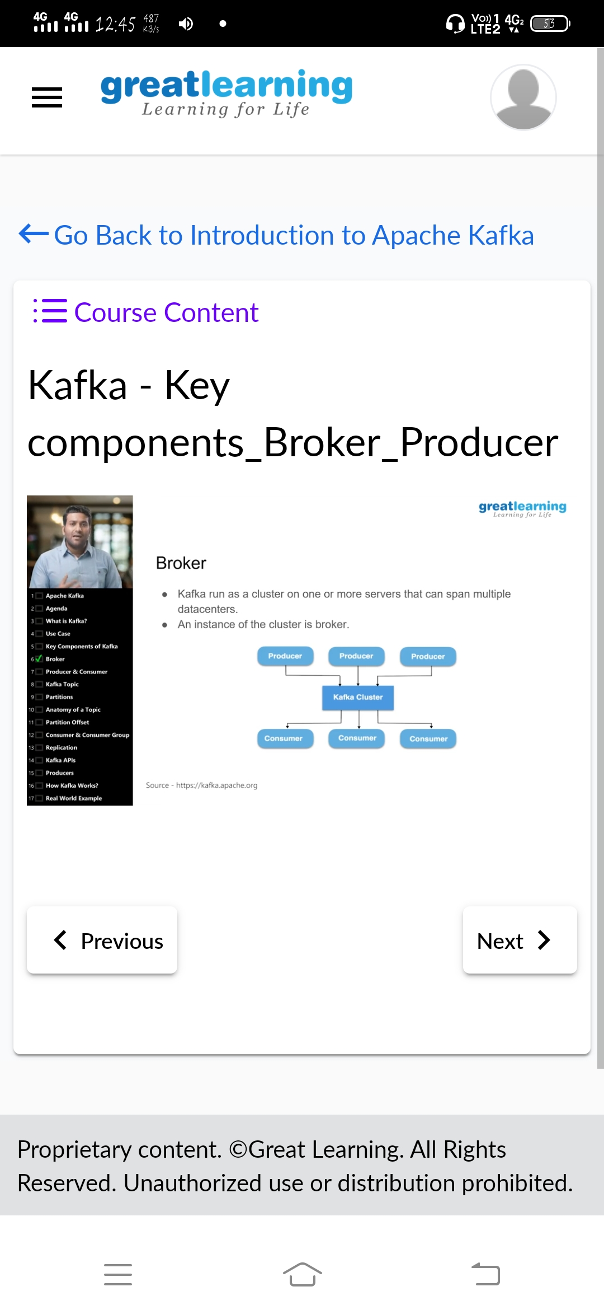

**CODING CHALLENGES DETAILS**: Every day we are given with new question of coding related to the language of java and c.

**Problem statement 1:** Write a C Program to rotate the matrix by K times Program in C

**Solution is uploaded in Github**

**Snapshot:**

